**Excel Assignment – 18**

1. What are comments and what is the importance if commenting in any code?

**Ans:** A VBA COMMENT is a green line of text that helps you to describe the written code. In simple words, a comment is a line of text which is not a code and VBA ignores it while executing the code.

Importance if commenting in any code:

1. Provide a brief explanation about a function, a line of code or a macro.
2. Temporally disable a line of code or a macro if you do not want to delete and rewrite it again.
3. Better organize your code for easier readability, modifications, and teamwork.
4. What is Call Statement and when do you use this statement?

**Ans:** Call Statement Transfers control to a Sub procedure, Function procedure, or dynamic-link library (DLL) procedure. The CALL statement transfers control from one object program to another within the run unit. The program containing the CALL statement is the calling program; the program identified in the CALL statement is the called subprogram.

This statement calls another application. This statement has the following syntax: call subsystem ([parametername = value. {, parametername = value}]); The call statement specifies optional parameters that call another application.

1. How do you compile a code in VBA? What are some of the problem that you might face when you don’t compile a code?

**Ans:** You can compile your VBA code by clicking Debug Menu → Compile VBA Project. A compile error for a missing “End if” part of an IF statement. Every individual line in the code is correct, but together, they don't represent a complete IF statement.

some of the problem that you might face when you don’t compile a code:

* 1. If you do not declare variables, but your Option Explicit is switched on at the top of your module, and then you run the macro, a compile error will occur.
  2. If you code refers to a procedure that does not exist, you will also get a compile error.
  3. If you create a loop using *[For..Each..Next](https://www.automateexcel.com/vba/for-each/)* or *[With..End With](https://www.automateexcel.com/vba/with-end-with/)* and forget to and the *Next* or the *End With*… you will also get a compile error.
  4. *If you are using an Object Library that is not part of Excel, but you are using the objects from the library in your variable declaration, you will also receive a compile error.*

1. What are hot keys in VBA? How can you create your own hot keys?

**Ans:** Hot /Shortcut keys in VBA

These shortcuts help when you are running your macros or stepping through each line of code to test and debug.

|  |  |  |
| --- | --- | --- |
| Shortcut | Windows | Mac |
| Jump between Excel and the VB Editor Window | Alt+F11 | Opt+F11 or Fn+Opt+F11 |
| Run Macro/Procedure | F5 | F5 |
| Step Through Each Line of Code | F8 | Cmd+Shift+i |
| Run to Cursor | Ctrl+F8 |  |
| Add a Break Point | F9 |  |
| Reset/stop code | Alt,R,R |  |
| Compile VBA Project | Alt,D,L |  |

## Navigating Through Code Modules & Procedures

These shortcuts will help you jump between procedures (macros) and quickly navigate through code module windows.

|  |  |  |
| --- | --- | --- |
| Shortcut | Windows | Mac |
| Flip through open code windows | Ctrl+Tab | Ctrl+Tab |
| Flip backwards through open code windows | Ctrl+Shift+Tab | Ctrl+Shift+Tab |
| Jump to Definition (procedure name that text cursor is in) | Shift+F2 |  |
| Jump to last position | Ctrl+Shift+F2 |  |
|  |  |  |
| Jump to previous/next procedure | Ctrl+Page Up/Down | Fn+Ctrl+Cmd+↑ or ↓ |
| Select the entire procedure | Ctrl+Shift+Page Down | Fn+Ctrl+Cmd+Shift+↓ |
| Find Window | Ctrl+F | Cmd+F |
| Replace Window | Ctrl+H | Cmd+Shift+H |

## Writing Code

These shortcuts help save time when writing code with tasks like autocompleting words, deleting lines, showing the Intellisense menu, and more.

|  |  |  |
| --- | --- | --- |
| Shortcut | Windows | Mac |
| Complete Word | Ctrl+Space | Ctrl+Space |
| Delete entire line | Ctrl+Y | Cmd+Y |
| Jumps to the beginning or end of a word | Ctrl+← or → | Cmd+←or → |
| Selects the entire word | Ctrl+Shift+→ or ← | Cmd+Shift+→ or ← |
| List properties/methods (Intellisense drop-down list) | Ctrl+J | Cmd+J |
| Quick Info | Ctrl+i | Cmd+i |

## VB Editor Windows

Open the windows and task panes that are commonly used within the VB Editor.

|  |  |  |
| --- | --- | --- |
| Shortcut | Windows | Mac |
| Immediate Window | Ctrl+G | Ctrl+Cmd+G |
| Project Explorer Window | Ctrl+R | Ctrl+Cmd+R |
| Properties Window | F4 |  |
| Insert a new code module | Alt,I,M |  |
| Insert a new userform | Alt,I,U |  |
| View userform code | F7 |  |
| Object Browser | F2 | Ctrl+Cmd+B |

Create your own hot keys:

1. On the Tools menu, point to Macro, and then click Macros.
2. In the Macro name box, enter the name of the macro you want to assign to a keyboard shortcut key.
3. Click Options.
4. If you want to run the macro by pressing a keyboard shortcut key, enter a letter in the Shortcut key box. You can use CTRL+ letter (for lowercase letters) or CTRL+SHIFT+ letter (for uppercase letters), where letter is any letter key on the keyboard. The shortcut key cannot use a number or special character, such as @ or #.

Note: The shortcut key will override any equivalent default Microsoft Excel shortcut keys while the workbook that contains the macro is open.

1. If you want to include a description of the macro, type it in the Description box.
2. Click OK.

5. Create a macro and shortcut key to find the square root of the following numbers

665, 89, 72, 86, 48, 32, 569, 7521

**Ans:**

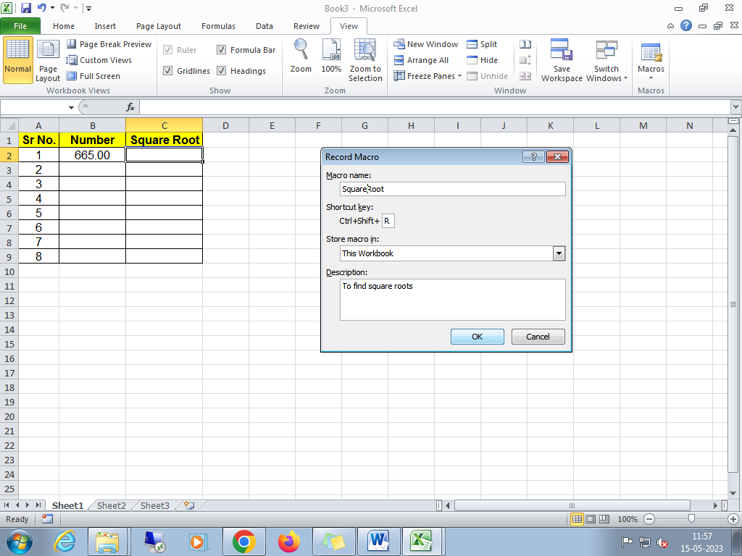

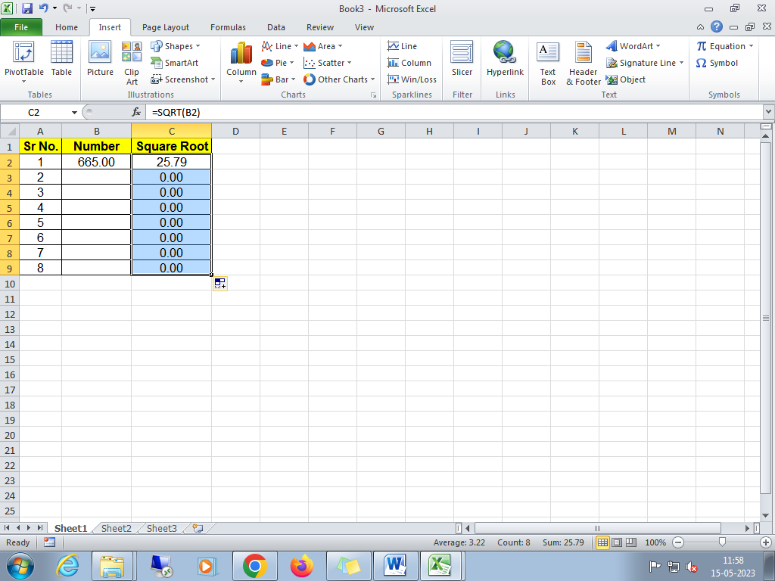

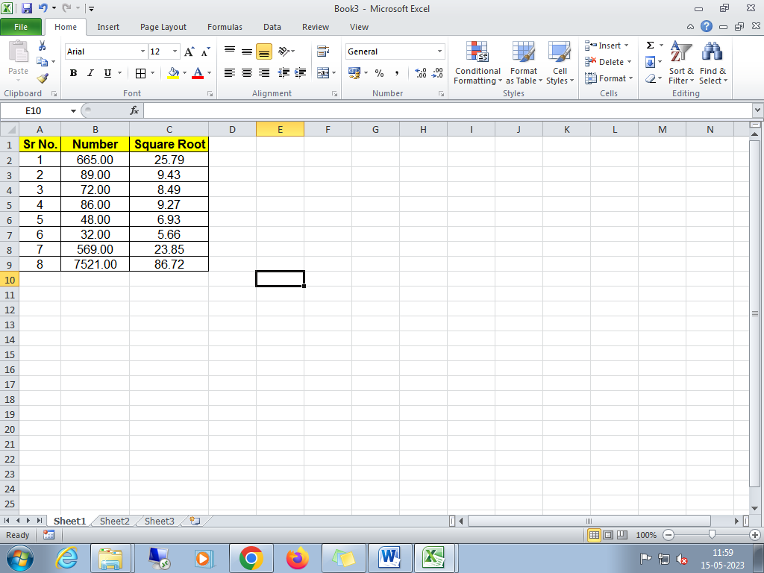

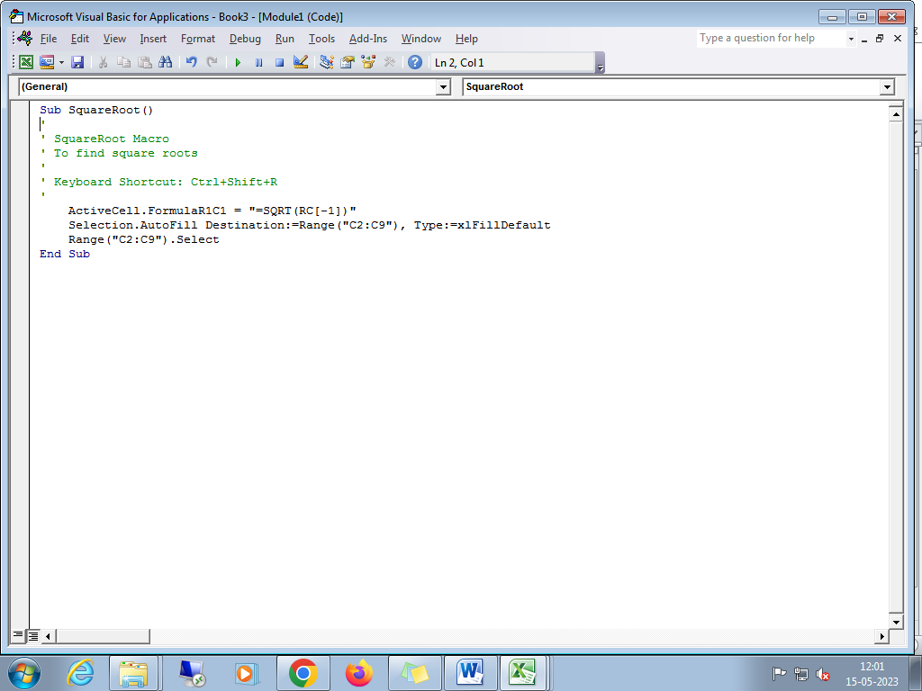

1. What are the shortcut keys used to?

a. Run the code : **F5**

b. Step into the code : **Shift+F8**

c. Step out of code: **Ctrl+Shift+F8**

d. Reset the code: **Alt+R+R**